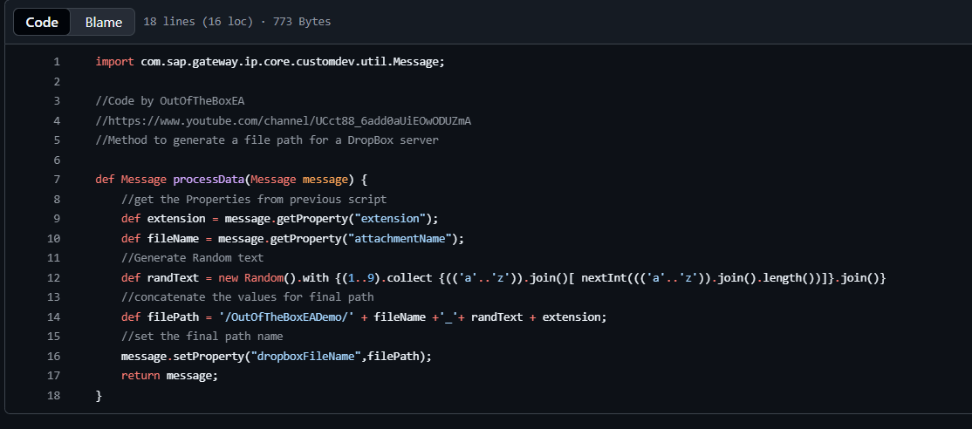
👍
I’ll explain this Groovy script for SAP CPI line-by-line, point-wise, in a beginner-friendly way.

1️⃣ Import Statement
import com.sap.gateway.ip.core.customdev.util.Message;
- Imports the Message class from SAP CPI.
- This class allows you to:
  - Read headers
  - Read properties
  - Modify the message
- Mandatory for CPI Groovy scripts.

2️⃣ Comments (Documentation)
//Code by OutOfTheBoxEA
//https://www.youtube.com/channel/UCct88_6add0aUiEOwODUZmA
//Method to generate a file path for a DropBox server
- These are comments
- They do not affect execution
- Used to:
  - Credit the author
  - Explain the purpose of the script

3️⃣ Method Definition
def Message processData(Message message) {
- processData is the default method SAP CPI calls
- Input parameter:
  - message → the CPI message object
- def Message → method returns a Message object
- Everything inside { } is executed during runtime

4️⃣ Read Property: File Extension
def extension = message.getProperty("extension");
- Fetches a property named "extension"
- Example value:
- .xml
- .json
- .csv
- Property must be set earlier (Content Modifier / previous script)

5️⃣ Read Property: File Name
def fileName = message.getProperty("attachmentName");
- Fetches another property
- Example:
- invoice
- order_123
- employeeData

6️⃣ Generate Random Text
def randText = new Random().with {
- Creates a Random object
- with {} allows cleaner Groovy syntax

🔹 Random Text Logic (Inside)
(1..9).collect {
- (1..9) → loop 9 times
- collect {} → collects output into a list

(('a'..'z')).join()[ nextInt((('a'..'z')).join().length())]
- ('a'..'z') → creates alphabet range
- .join() → converts to string "abcdefghijklmnopqrstuvwxyz"
- nextInt(length) → picks a random index
- Final result → random lowercase letter

}.join()
- Joins 9 random letters into one string
- Example output:
- xkqtrpmza

7️⃣ Build the Final File Path
def filePath = '/OutOfTheBoxEADemo/' + fileName +'_'+ randText + extension;
- Combines:
  - Folder path
  - Original filename
  - Random text
  - Extension
🔍 Example:
/OutOfTheBoxEADemo/invoice_xkqtrpmza.xml

8️⃣ Set Property for Dropbox Adapter
message.setProperty("dropboxFileName",filePath);
- Saves the final path into a message property
- This property is later used by:
  - Dropbox Adapter
  - Or another step in iFlow

9️⃣ Return the Message
return message;
- Mandatory in CPI Groovy
- Sends the modified message back to the iFlow

🔚 Summary (One Look)
✔ Reads filename & extension
✔ Generates random string
✔ Creates unique Dropbox file path
✔ Stores it in message property

🧠 Why This Script Is Useful in SAP CPI
- Avoids file overwrite in Dropbox
- Ensures unique filenames
- Common in SFTP / Dropbox / FTP adapters

If you want, I can also:
- 🔁 Simplify this code
- 🧪 Show sample input & output
- 🧩 Convert it to CPI interview explanation
- ✍️ Add inline comments in code
Just tell me 😊

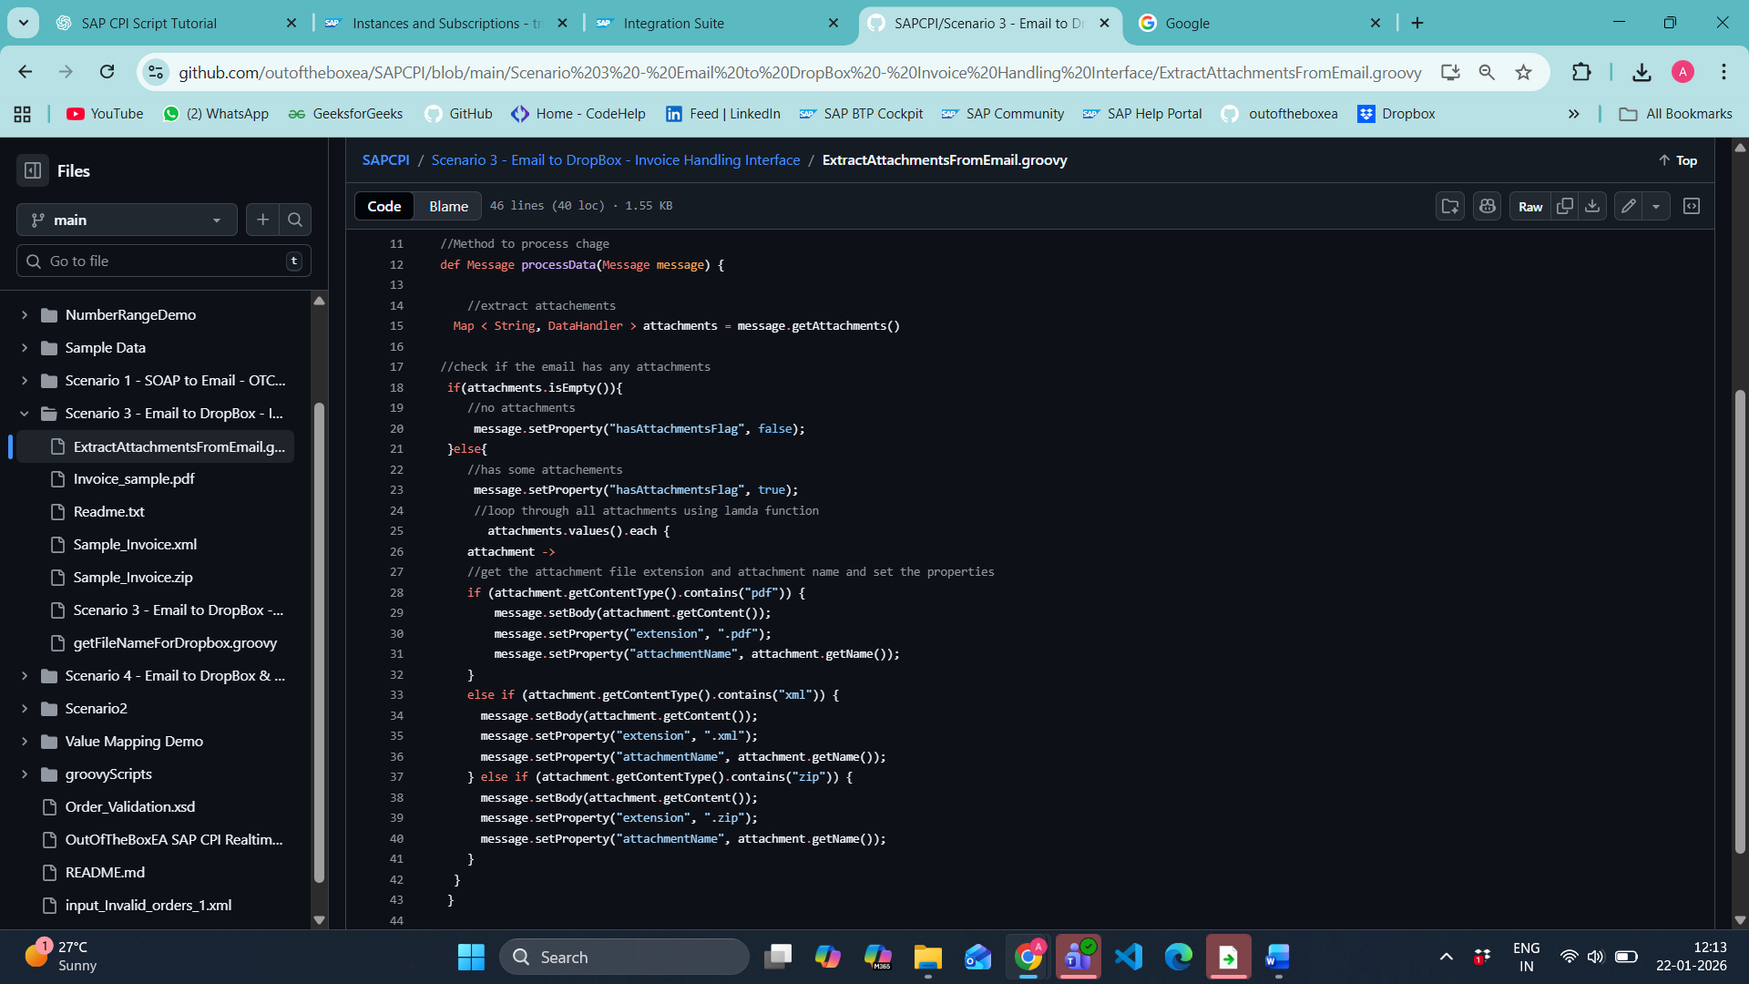
Sure 👍
Below is a clear, line-by-line explanation, point-wise, exactly how this SAP CPI Groovy script works.

🔹 1️⃣ Import Statements
import com.sap.gateway.ip.core.customdev.util.Message
- Imports the SAP CPI Message object
- Used to read/write:
  - Body
  - Headers
  - Properties
  - Attachments

import java.util.Map
import java.util.Iterator
- Map → used to store attachments as key–value pairs
- Iterator → generally used for looping (not explicitly used later, but safe)

import javax.activation.DataHandler
- Very important
- DataHandler represents attachments (PDF, XML, ZIP, etc.)
- Used to:
  - Read attachment content
  - Read attachment name
  - Read content type

🔹 2️⃣ Comments (Documentation)
//Code by OutOfTheBoxEA
//https://www.youtube.com/channel/UCct88_6add0aUiEOwODUZmA
//Method to extract attachments from a message in SAP CPI
- Just documentation
- No impact on execution
- Explains purpose of script

🔹 3️⃣ Method Definition
def Message processData(Message message) {
- processData → default CPI entry method
- message → current CPI message
- Returns the modified Message object

🔹 4️⃣ Extract Attachments from Message
Map < String, DataHandler > attachments = message.getAttachments()
- Fetches all attachments
- Stored as:
- Key → Attachment ID
- Value → DataHandler (actual attachment)
- Example attachments:
  - invoice.pdf
  - order.xml
  - data.zip

🔹 5️⃣ Check if Attachments Exist
if(attachments.isEmpty()){
- Checks whether the message has zero attachments

❌ No Attachments Case
message.setProperty("hasAttachmentsFlag", false);
- Sets CPI property:
- hasAttachmentsFlag = false
- Useful for:
  - Router condition
  - Exception handling
  - Skipping further processing

🔹 6️⃣ If Attachments Are Present
}else{
message.setProperty("hasAttachmentsFlag", true);
- Indicates attachments exist
- Used later in the iFlow

🔹 7️⃣ Loop Through All Attachments
attachments.values().each {
attachment ->
- attachments.values() → gets all DataHandler objects
- each {} → Groovy loop (lambda style)
- attachment → one attachment at a time

🔹 8️⃣ Check Attachment Type – PDF
if (attachment.getContentType().contains("pdf")) {
- Checks MIME type
- Example:
- application/pdf

message.setBody(attachment.getContent());
- Sets attachment content as message body
- This allows:
  - Writing to SFTP
  - Uploading to Dropbox
  - Further processing

message.setProperty("extension", ".pdf");
message.setProperty("attachmentName", attachment.getName());
- Saves:
  - File extension
  - File name
- Example:
- invoice.pdf

🔹 9️⃣ Check Attachment Type – XML
else if (attachment.getContentType().contains("xml")) {
- Matches:
- application/xml
- text/xml
message.setBody(attachment.getContent());
message.setProperty("extension", ".xml");
message.setProperty("attachmentName", attachment.getName());
- Same logic as PDF
- Just changes extension

🔹 🔟 Check Attachment Type – ZIP
else if (attachment.getContentType().contains("zip")) {
- Matches:
- application/zip
message.setBody(attachment.getContent());
message.setProperty("extension", ".zip");
message.setProperty("attachmentName", attachment.getName());
- Handles ZIP attachments

🔹 1️⃣1️⃣ End of Loops & Conditions
}
}
- Ends:
  - Attachment loop
  - if–else condition

🔹 1️⃣2️⃣ Return Message
return message
}
- Sends modified message back to CPI flow
- Mandatory step

✅ Final Summary (Interview-Ready)
✔ Extracts all attachments from CPI message
✔ Checks if attachments exist
✔ Identifies attachment type (PDF / XML / ZIP)
✔ Sets attachment as message body
✔ Stores filename & extension as properties
✔ Enables routing & adapter usage

🧠 Real CPI Use Case
- 📩 Email Adapter → Read attachments
- 📤 Dropbox / SFTP Adapter → Upload files
- 🔁 Router → Based on hasAttachmentsFlag
- 🔐 Avoid overwrite using filename logic

If you want next:
- 🧩 How Router condition works with this
- 🔄 How to handle multiple attachments
- ❗ Common CPI errors with attachments
- ✍️ Interview explanation in 5 lines
Just tell me 😊
❗ Common CPI errors with attachments ✍️ Interview explanation in 5 lines
Below is exactly what you asked for ✅
Point-wise, SAP CPI–focused, and interview-ready.

❗ Common SAP CPI Errors with Attachments
1️⃣ Attachment Not Found
- Error: Attachments map is empty
- Reason: Email/File adapter not configured to fetch attachments
- Fix:
  - Enable “Read Attachments” in Email Adapter
  - Check file name pattern in File/SFTP adapter

2️⃣ java.lang.NullPointerException
- Error: Script fails while accessing attachment
- Reason: Attachment property or content is null
- Fix:
if(!attachments.isEmpty()) { ... }

3️⃣ Wrong Content-Type Detection
- Error: PDF/XML not detected correctly
- Reason: MIME type differs
(e.g. application/octet-stream)
- Fix:
attachment.getName().endsWith(".pdf")

4️⃣ Only Last Attachment Processed
- Error: Multiple attachments but only one uploaded
- Reason: setBody() overwrites previous content
- Fix:
- Use General Splitter
- Or process attachments one-by-one

5️⃣ File Corruption After Upload
- Error: Downloaded file cannot open
- Reason: Wrong transfer mode or encoding
- Fix:
- Set adapter Binary Mode
- Avoid Content Modifier after binary body

6️⃣ Filename Missing in Adapter
- Error: File uploaded with random name
- Reason: Filename property not mapped
- Fix:
- Pass filename via property (e.g. dropboxFileName)

✍️ SAP CPI Interview Explanation (5 Lines)
“In SAP CPI, attachments are handled using the Message API via Groovy scripts.
Attachments are accessed as DataHandler objects and can be looped through using the attachments map.
The attachment content can be set as the message body for further processing or adapter usage.
Properties like filename and extension are extracted for routing or dynamic file naming.
Common challenges include MIME type mismatch, null attachments, and handling multiple files.”

